ABDUL AZIZ -- abdul.aziz@nu.edu.pk

MUBASHRA FAYAZ-- mubashra.fayyaz@nu.edu.pk

**Programming Fundamentals**

**Lab Manual-01**



Overview

1. Problem Solving

2. Types of Problems

3. Problem Solving and Computers

4. Difficulties in Problem Solving

5. Problem Solving and Concepts of Computers a. Types of Problems

b. Constants and Variables c. Data Types

d. Functions e. Operators

f. Expressions and Equations

**Problem Solving**

There are six steps to follow to ensure the best decision. These six steps in problem solving include the following:

1. Identify the Problem.

2. Understand the Problem.

3. Identify alternative ways to solve the Problem.

4. Select the best way to solve the Problem.

5. List the Instructions.

6. Evaluate the Solution.

**Types of Solutions for Problems**

1. Algorithmic Solution

2. Heuristic Solution

**Problem Solving and Computers**

Computers are built to deal with algorithmic solutions, which are often difficult or very time consuming for humans. People are better than computers at developing heuristic solutions.

● Solutions ⇒ Instructions

● Results ⇒ Outcome

● Program ⇒ Solution in a particular Computer Language



**Difficulties with Problem Solving**

➔ Lack of problem solving experience

➔ Inadequate solution steps

➔ Incorrect problem definition

➔ Alternatives chosen incorrectly

➔ Invalid logic

➔ Incorrect solution evaluation

Exercise:

Complete the six problem-solving steps to solve the problem of finding the largest number out of three numbers. List the specific steps that would enable another person to find the largest among three numbers presented.

**Types of Problems**

1. **Computational**: Involving Mathematical Processing

2. **Logical**: Involving Relational or Logical Processing

3. **Repetitive**: Involving repeating set of mathematical/logical instructions

**Constants and Variables**

Constants : A specific alphabetical and/or numeric value that is never changed.

For Ex. **PI** - 3.14159

Variables : The value that can be changed.

For Ex. ShoeCost = 56.00 and ShoeCost = 35.00

Naming Convention

Specific to a Company. Helps programmers to be a part of an environment and follow and specified conventions

Rules for Naming Conventions

1. Name a variable according to what it represents. Create as short name as possible but one that clearly represents the variable.

2. Do not use spaces in a variable name.

3. Start a variable with a letter.

4. Do not use dash ( - ) or any symbol that is used as a mathematical operator.

5. Use the same variable name to represent a specific data.

6. Be consistent when using upper and lower-case characters.



7. Use the naming convention specified by the company where you work.

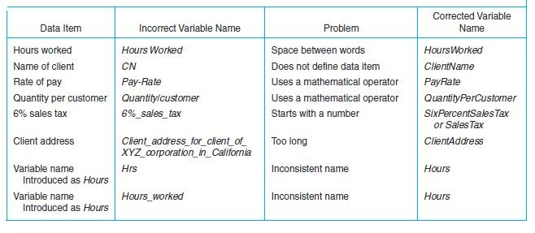

**Data Types**

The data the computer uses are of many different types. Computers must be told the **data type**

of each variable or constant.

Numeric Data

Numeric data include all types of numbers.

**Integers** ⇒ Whole Numbers

**Real Numbers** ⇒ Whole Numbers + Decimal Parts

Character Data

Alphanumeric data contains of al single-digit numbers, letters and special characters available to the computer.

**String Data** ⇒ more than one character are put together.

**Concatenation** ⇒ When two pieces of character date are joined.

Logical Data

Consist of two values in the data set - True and False.

Other Data Types

**Date Data Type** ⇒ Is a number for the date that is the number of days from a certain date in the past.

**User Defined Data Types** ⇒ Programmers may define their own data types.

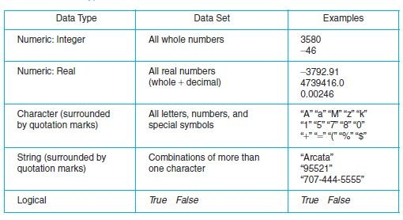

**Functions**

Functions are small sets of instruction that perform specific tasks and return values. The form of a function is the name of the function followed by an open parenthesis, followed by the data needed to perform the function and concluded by a closed parenthesis:

FunctionName( data )

**Parameter :** Data listed as a part of the function

For Ex. **Sqrt(N)** -- **Sqrt** is the name of the function and **N** is the parameter.

Types of Function

1. Mathematical ⇒ Calculate mathematical values such as square root, absolute value etc.

2. String ⇒ Manipulate string variables such as copy , length etc.

3. Conversion ⇒ Convert data from on data type to another.

4. Statistical ⇒ Calculate things such as Max , Min etc

5. Utility ⇒ Used in generating Reports such as Date and Time function etc.

**Operators**

Operators are the data connectors within expressions and equations. They tell the computer how to process the data. They also tell the computer what type of processing (mathematical, logical,

or whatever) needs to be done. The types of operators used in calculations and problem solving include mathematical, relational, and logical operators.

**Operands** ⇒ data that the operator connects and processes.

**Resultant** ⇒ result when the operation is completed.

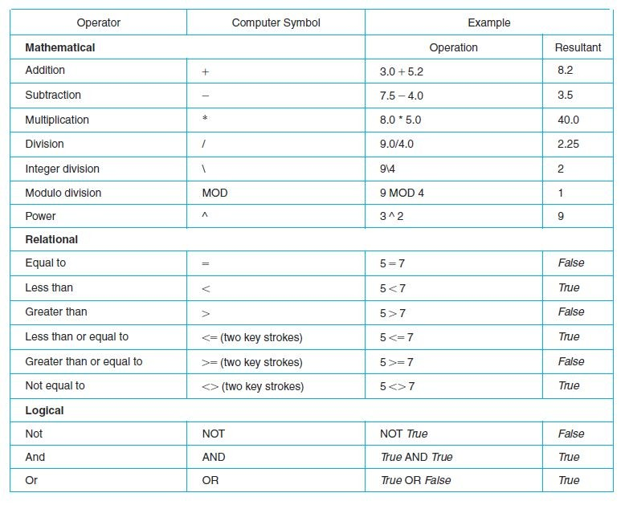

Hierarchy

These mathematical, relational, and logical operators have a hierarchy, or precedence, an order in which their operations take place.

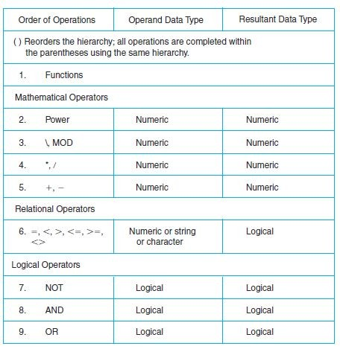

**Expressions and Equations**

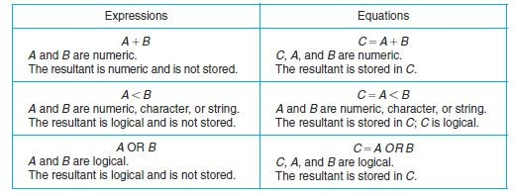

Exercises:

1. Fill the table with Variables name and data types:

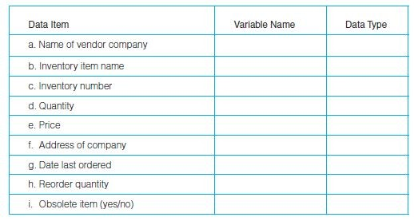

2. Find the result of the following operations:

a. 5 + 4 b. 10/2

c. True OR False



d. 20 MOD 3 e. 5 < 8

f. 25 MOD 70 g. “A” 7 “H”

h. NOT True i. 25\70

j. False AND True k. 20 * 0.5

l. 35 <= 35 m. 35/7

n. False OR False o. True AND True p. 50 MOD 5

q. -35 < 67

3. Using the hierarchy chart, list the order in which the following operations would be processed. (Remember: Operations are processed left to right within a level in the hierarchy table.)

a. +, -, *

b. /, \, =

c. OR, *, <

d. NOT, AND, *

e. NOT, >, +

f. AND, OR, NOT

g. <, AND, >, +

h. *, ^, +

i. NOT, +, \

j. MOD, \, <

4. Set up an equation to calculate the following (create your own variable names):

a. The area of a room.

b. The wall area of a room including windows and doors.

c. The wall area of a room not including two windows and a door.

d. The number of miles given a number of feet. (Use 5,280 feet per mile.)

e. The percent increase (or decrease) of a value given the beginning number and the ending number. How would the result differ between increase and decrease?



5. What is wrong with these variable names? Can you correct them?

a. City Name referencing the name of a city. b. Client-name referencing a client name.

c. City/State referencing a city and state. d. LN referencing a last name.

e. Street address

f. Q for a quantity of books

g. Street_Address_for_Joe’s_Hardware_Supply_Incorporated_Client

6. Steve Thompson bought and charged an electric saw on Date1 and made the first payment on Date2. Write an equation to calculate how many days (Days) elapsed between the two dates using a Function (for Charging)

Days =

7. Roger would like to know the average of his test scores. Write an equation that would calculate the average given five test scores. Write the equation with and without using a function.

